IAM-CORE GUIDE:

Done by: Emile EL HOYEK

Description:

The subject Identity Management’s main goal is to manage users of an Information System.

As many basic concepts, it can be much improved, especially when you want to bring security to this management. The application will be able to:

* Authenticate to use the application.
* Create, modify and delete user information.
* Be robust, capable of good performance.
* Store the data in a database.

Conception:

The project contains four major classes:

The ConsoleLauncher class that contains the main function to run the project and this function contains the menu of the application and the authentication of the user.

The Identity class that contains the credentials of the identity user you want to create. In this project there is the User ID, Name, Email and Birthdate.

The CreateActivity class that contains the functions create, update and delete and connects to the database to add or do changes to a specified user.

The IdentityJDBCDAO which contains the fucntions to store the data in the database.

Global activity diagram:

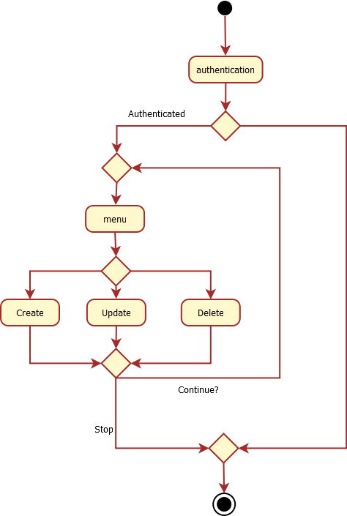

Authenticate and create user:

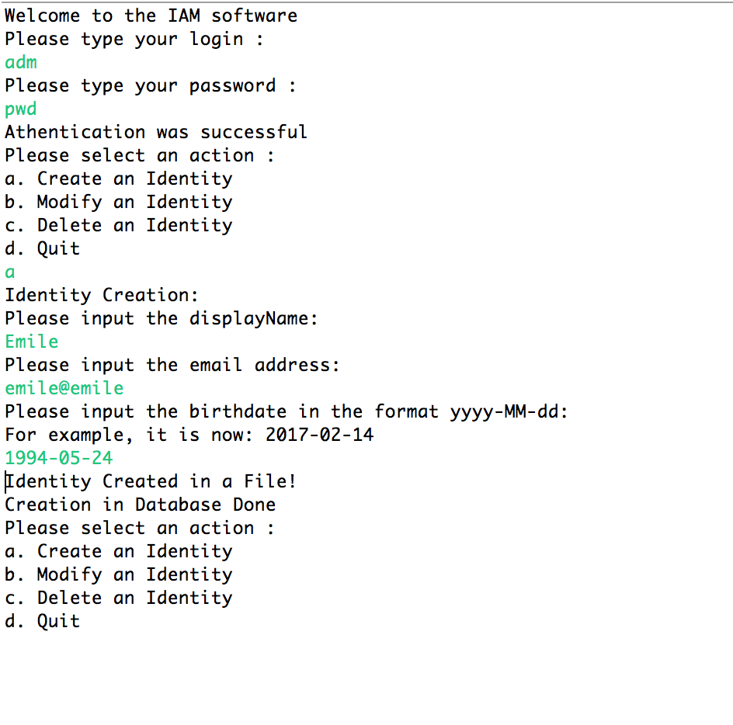

Modify user:

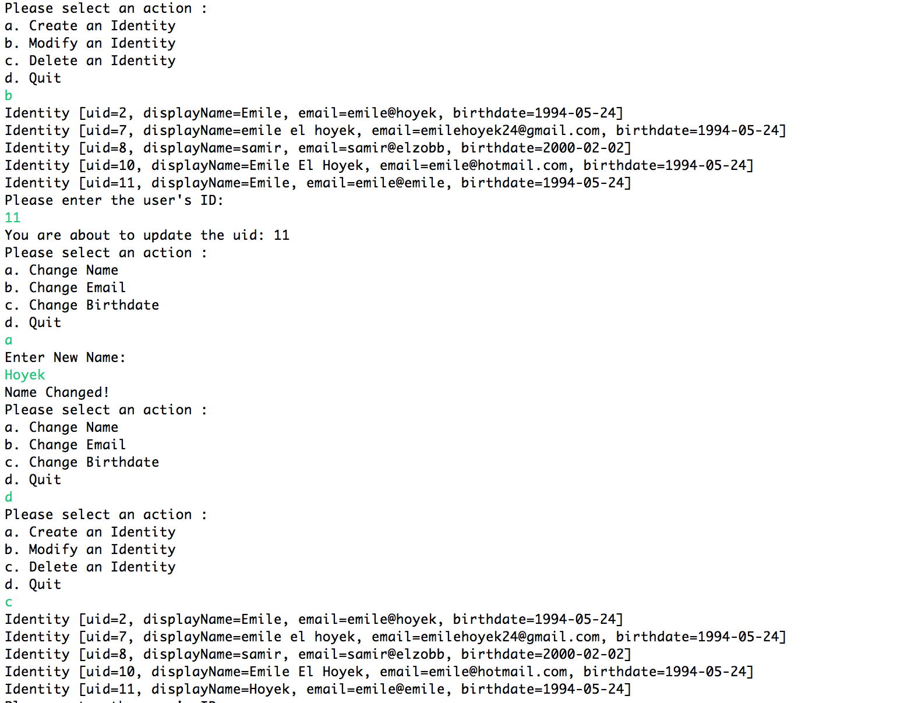

Delete user:

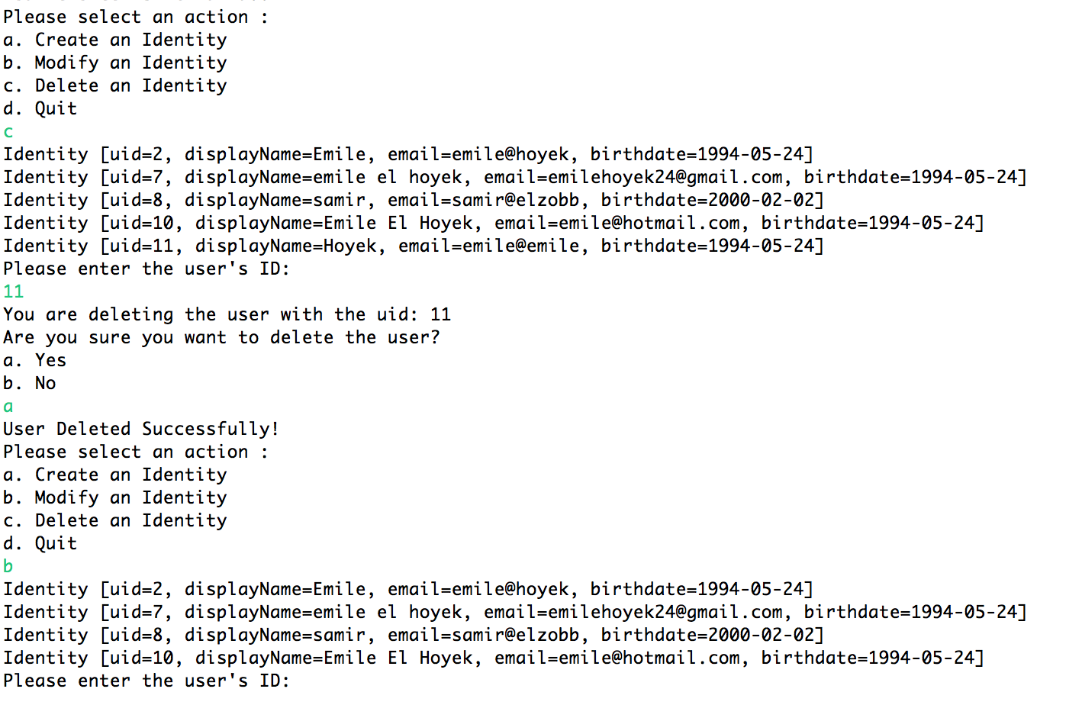

Database at the end:

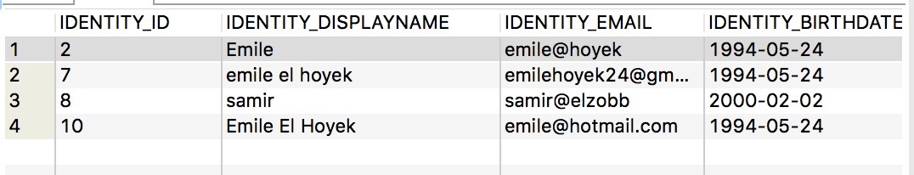

Scope of the application (limits, evolutions):

There is a problem with the scanner so I’ve put scanner.next instead of scanner.nextLine

Because with the Do While loop, the scanner was jumping a step.

We can add an interface for the user for him to use the application easily and this would help with easier and lesser coding since we can delete with a push of a button for example.